THE INNOVATION AWARD

This competition is kindly sponsored by

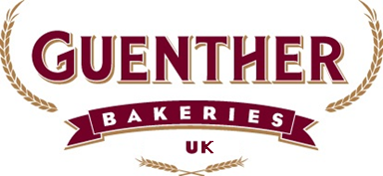

This competition is open to all ABST student and trainee members

The winner will receive £100, the Innovation Award Trophy, an A.B.S.T. Medal and Diploma
Second place will receive £50, an A.B.S.T. Medal and Diploma, Third place will receive £25, an A.B.S.T. Medal and Diploma

Produce: 2 x Innovative Burger Bun Products:

Provide 2 samples of one innovative burger bun suitable for the fast food industry in the serving of a beef burger style product.

and 2 samples of one innovative burger bun suitable for the fast food industry in the serving of a chicken burger style product.

- Shape must be a standard burger bun round. Can be stamped or have a cut design on crown.
- Bun size should be approx. 4 inches in diameter for beef and approx. 4.5 inches in diameter for chicken.
- No restrictions on height.
- Weight must be between 74-80g for the 4.5 inch and 57-63g for the 4 inch on the day of judging.
- Toppings must be added pre-bake and be shelf stable e.g. Rice cones, paprika.
- The following allergens must not be part of your recipe: Nuts, Soya.
- The following must also not be part of your innovation: additions with low ambient shelf life e.g. fresh fruit/vegetables.
- Inclusions can be added to the dough e.g. Cajun flavouring/BBQ flavouring.

1 x A4 sheet Recipe & Concept Idea

Provide a printed A4 paper sheet containing the recipe (please highlight all Allergens in bold) and method of production. In this you can also provide a build suggestion (including meat patty/chicken, sauces, salads etc.) for your concept.

- Please provide reasoning behind your idea for instance, if a Mexican bun is made, is this because Mexican flavours are trending in the UK or are Mexican restaurants being opened at an increasing rate compared to American smokehouses…

Please display the 4 buns uncut and unfilled on a square silver cake board 25cm x 25cm or smaller.

You will be marked on the following
- Visual appeal □ Marketing potential □ Flavour
- Innovation □ Texture

Please note all entries submitted may be photographed and used for press release purposes for no additional remuneration. In acceptance of entry all entrants’ names and names of colleges may be photographed and used for publicity purposes by the sponsor. By entering the products you agree that any recipes submitted will become the property of Guenther Bakeries UK and no remuneration will be given.

